A G E N D A
Meeting of Bowes Parish Council on
Tuesday 16th May 2023 at 7.30pm at Bowes School

1. Apologies –

2. Minutes of the Meeting held Tuesday 18th April 2023.

3. Matters arising (unless dealt with later in agenda)

4. Finance & Accounts – See summary below
Receipts since last meeting £11.37 interest £100.00 Coronation Grant from Durham County Council £350.00 G Brownless £80.00 WM Allison & Sons.
Expenses since last meeting £350.00 – Shorts Associates (coronation mugs) £61.10 CDALC annual membership fee

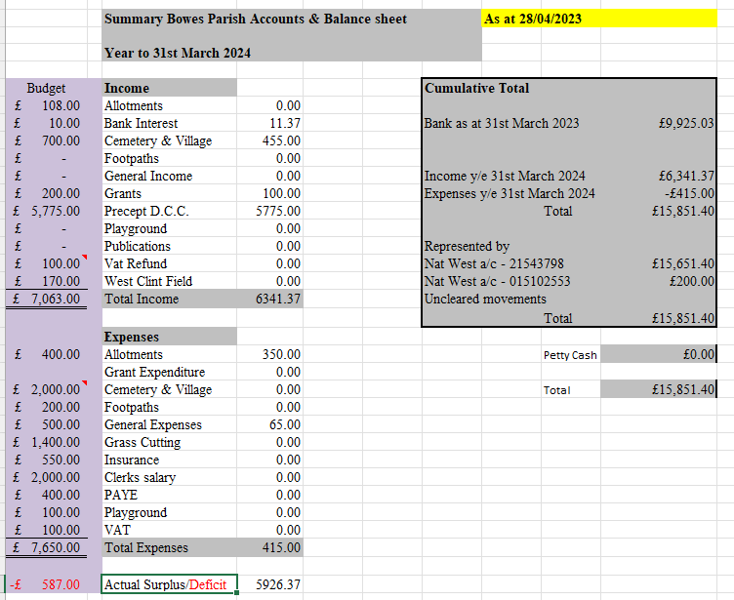

5. Planning
DM/23/00936FPA Havelock House, -Garage resubmissions.

6. Correspondence

7. Cemetery & Village maintenance
Clerk has sent out all of the new agreements.

8. Allotments

9. Play Park

10. Parish Paths

11. AOB

Liability Insurance Dates AR Toward 15/04/2024
Next election date – 4th May 2025
Accessibility Statement review date: August

