Minutes of the Meeting of Bowes Parish Council
held at Bowes School Wednesday 11th November 2015

The meeting commenced at 7.30pm

Present: Cllr Carlisle, Cllr White, Cllr Brown and Mrs H Overfield

- Apologies Cllr Hughes, Cllr Wake

- Minutes of the Meeting held Tuesday 14th October 2015 agreed to be a true record, approved by
Cllr Brown seconded by Cllr Carlisle.

- Matters arising (unless dealt with later in the agenda)

4. Finance & Accounts – See summary below
Receipts since last meeting £73.50 J Blenkiron
Expenses since last meeting £26.80 K Adams

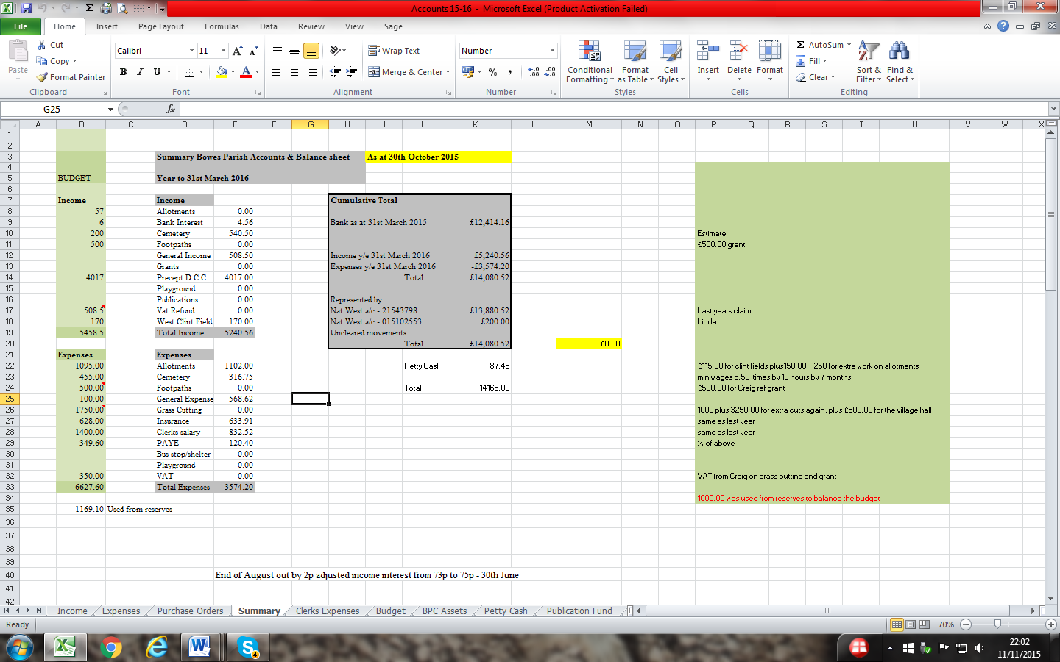
Clerk supplied the councillors with copies of the bank statements to verify the bank reconcilliations. Approved by Cllr Brown

The accounts were approved to be a true record by Cllr Carlisle, seconded by Cllr Brown.

5. Planning
Mr James Harker – Former Department of Transport – Erection of 14 no dwellings with associated ancillary development – Clerk to reply- A Stone Culvert feeds the large pipe mentioned in the archaeological survey, this carries fresh water down the north side of Bowes Street and must not in any circumstances be stopped up. If there is any need to breach the drain the Parish Council and the Local History group would be interested in running a dye test through several of the wells located in the village. We feel that there are too many accesses onto the main road, furthermore will the cars from properties 1 – 10 have to reverse out onto the main road. Couldn’t a road be taken around the back servicing all the houses? The land immediately to the west of this site is currently for sale and may well by suitable for housing development. The current proposal means that yet another access will have to be created between plot 14 and the A66 slip road if any future developments were permitted. Will there be any restriction on parking on the road and if so how will it be enforced. This is a far busier road than the main street in Bowes.
Letter from Andrew Thompson reference a meeting regarding the wind turbines – Clerk to reply – The Parish Council do not meet with applicants, we make our decisions based on the application submitted.
Mr Peter Coverdale – Levy Pool – Bowes – Double garage – no observations

Mr Ettey – Bar Gap Farm – Variation of condition 2 pursuant to planning permission 6/2011/0195/DM for the addition of a single storey side extension – no observations

6. Correspondence
Nothing of note.

7. Cemetery & Village maintenance
The grass has started to grow at the west side of the top of the steps on its own accord.

8 Allotments
Clerk to e-mail allotment holders regarding the rent increase and the new agreement that will need signing. E-mails as follows:-

The Parish council will write off up to £1040.00 of capital spend in the creation of the new allotment area in West Clint field. No more allotments will be created in the foreseeable future in order to retain a realistic chance of re-letting the remaining part of West Clint Field. The Parish Council are happy for the field rent to subsidise the allotment rent, which in turn is due to pay the Lords in Trust and for minor repairs. The Lords in Trust have again requested a rent increase over the period of 2016 – 2018, which we have not yet agreed to. We are already paying more than twice as much as in 2007 and therefore the Parish Council has no option but to double the allotment rent to £12.00 per year for a full allotment. This will be reviewed annually henceforward.

9 Play Park
Cllr Brown has repaired the fence.

10 Parish Paths
Nothing to report.

11 AOB
3 lights are off again at Guide Post Corner, clerk to log with Durham County Council.

Meeting closed at 8.45

Section 17 Law & Disorder Act. It was felt the above would have a positive effect.

